**The Growth Programme Coach**  
  
The growth programme coach (GPC) is a role taken up by an unpaid, voluntary employee of Exchange vzw., in the context of managing the growth programmes. The growth programme coach holds a trust position of core volunteer with the organisation and, as such, is also involved in validating its vision and overall operation. In essence, the GPC is the 'counterpart' North of the South entrepreneur, with whom Exchange vzw. engages for a longer-term growth programme.

Context:

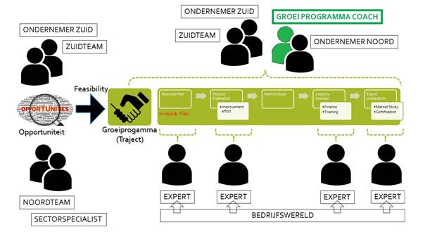

Exchange vzw. supports private entrepreneurship in Sub-Saharan Africa in the form of cooperation in a growth programme.   
The impetus for a growth programme comes from an opportunity around private entrepreneurship in the South, presented to Exchange or identified by the employees themselves in the South or North team. After a preparatory phase, a preliminary study, in which the South entrepreneur's ambition is tested against Exchange's possibilities and its selection criteria of sustainability, an agreement is concluded with the South entrepreneur on cooperation and longer-term support, as indicated above. At that point, the growth programme coach is appointed. Here, the GPC assumes the role of project manager in classic project management terminology: he is counterpart of the South Entrepreneur in the growth story and with his follow-up activity strengthens its chances of success.   
  
**Assignments of the growth programme coach**

The programme coach is a volunteer who commits to supervising a growth programme of longer duration over its duration and to help monitor its chances of success.

- The growth programme coach takes the time to thoroughly get to know the South Entrepreneur, his company and his ambition and the role, which Exchange is willing and able to play in it.

- At the start of his assignment, the growth programme coach develops two essential documents on the growth programme, namely the description of the 'scope' and the 'plan' of the growth programme. Once drafted and accepted, the GPC will help implement these agreements while monitoring their boundaries. All accepted substantive changes are documented as 'scope changes', all plan changes as 'planning changes'.

- Together with the country programme manager from the North Team, the GPC defines the content of specific technical assignments to support its growth programme and helps the GPC choose the implementing expert or technician. The GPC takes into account availability at the South Entrepreneur and the appropriateness of timing for execution. The GPC includes the pre-departure briefing and ensures reporting after execution of the expert assignment.

- The GPC acts as the South Entrepreneur's counterpart and is committed to the success of the South Entrepreneur's ambition. This entails regular contact and availability via mail or social media, exchange of tips and ideas, search for efficient cooperation and attention to local context, economic and socio-cultural uniqueness.

- The GPC personalises the specific growth programme within the operation of Exchange. He informs interested parties (companies, organisations and individuals) in the North about the growth programme, at their request or looks for possible partners for cooperation himself. At the request of the country programme manager, the GPC will promote and share knowledge in the North about the South Enterprise and its associated growth programme. This may involve presentations and performances, business contacts, interviews or participation in workshops.

- The GPC will participate in the consultation meeting of its country programme manager and, as a core volunteer, in the consultation meetings between growth programme coaches, which Exchange organises.   
  
**Duration of assignment**

In principle, the growth programme coach assumes his role for the entire duration of the growth programme, as stipulated in the document 'finality of the entrepreneurial growth programme', which may run over several years. However, as a volunteer, the GPC can discontinue his assignment on simple request with transfer to another GPC. Exchange also retains the right of closing the assignment or assigning it to someone else at any time, without having to formulate a justification.  
  
**Resources provided**

The documentation of a growth programme is based on that of 'project management practice'.   
The GPC can receive a short training course on 'project management', provided by Exchange, if required. Templates and examples are then available for the preparation of basic documents, as is all written information, which was prepared in the preliminary process. The relevant country programme manager in the North Team, is the permanent point of contact within Exchange for all questions of support and logistics, which require the execution of the assignment.  
  
**Support**

The growth programme coach is not supposed to contribute financially to the operation of Exchange. Although his performed time is not remunerated, the material costs of supporting his contribution fall at the expense of Exchange and, in particular, the full cost of the annual growth programme management trip and its preparation.

For its preparation, study and documentation work, participation in seminars and presentations, the GPC in the North has an annual budget of up to EUR 1,000, which it can spend to the best of its ability and recover based on proof of expenditure. This may also include travel expenses. The GPC is free to make those travel expenses by the means it chooses and can justify a reimbursement request of up to EUR 12.50 per single travel expense.  
  
**Selection criteria**

In principle, the position is open to men and women, senior and junior profiles, Belgians and non-Belgians, although in certain cases specific expectations regarding e.g. language skills and competence or expertise may be determined. Exchange provides no further details on the selection process.